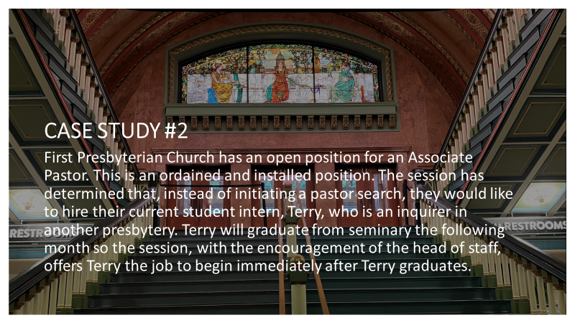

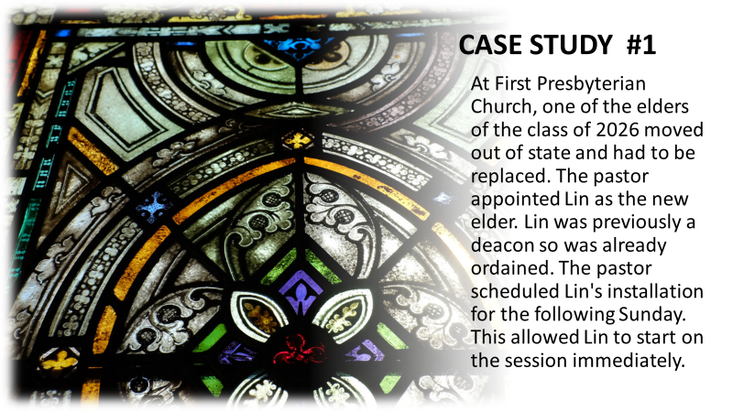

TRUE OR FALSE

- The Congregation can vote to request Presbytery to end the Pastoral Relationship with an Installed Pastor.

- The Clerk of Session has to be an active Elder on the Church Session.

- Two active Elders currently members of Session can serve on the Church Nominating Committee.

- Presbytery may appoint a pastor for church when it is vacant.

- Being Moderator of the church session means the Moderator can vote at Session meetings.

