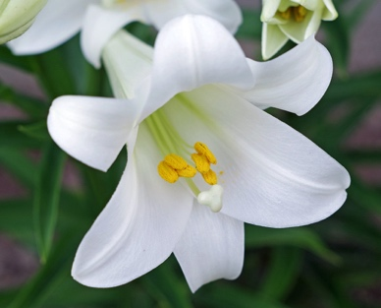
EASTER FLOWERS 2024
The sanctuary of Tuckahoe will be decorated with memorial flowers for Easter Sunday worship. This year there will be white lilies and hydrangeas in various colors. Following Worship on Easter Sunday, please pick up your plants to enjoy at home or in your gardens.
Lilies will be $12.00 per plant and the hydrangeas will be $16.00 per plant.
Your dedication will help defray the costs of fresh flowers throughout the year.
If you would like to have your dedication listed in the church bulletin, please either:
- Fill out this form and return it with your check made payable to Tuckahoe Presbyterian Church, “Easter flowers” in the memo line, to the church office (via mail or ‘In-box’ on the office counter). OR
- Fill out this online form on our website and pay online with a credit card through your PayPal account (‘Giving’ tab at top right, choose ‘Special Gift’, in special designation type ‘Easter flowers’, click ‘Give’).
The deadline to order and have your dedication in the bulletin is Friday, March 22nd.
Thank you for your support of the flower fund at Tuckahoe!

Please Print!
Given By:
___________________________________________________________________________________

In loving memory of:
___________________________________________________________________________________

___________________________________________________________________________________

___________________________________________________________________________________

In honor of:

Number of Lilies: ___________________ Number of Hydrangeas: ______________
($12 each) ($16 each)

Payment enclosed: Amount: _______________ Date: ________________________

I will pay on-line: Amount: _______________ Date: _______________________

I will pick up my flowers ____ Please deliver my flowers to homebound ____

email to office@tuckahoepres.org or mail to
TPC 7000 Park Ave Richmond, VA 23226

