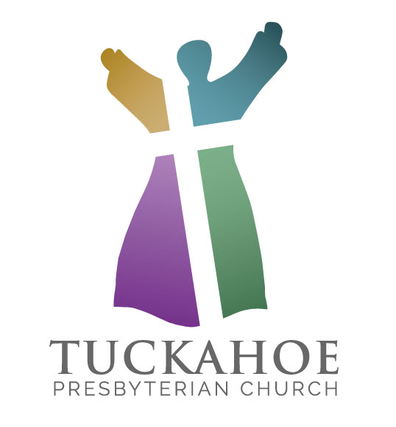
Called by God
to be the heart, voice, hands and feet of
Christ where the Spirit leads us.

Service for the Lord’s Day
Tuckahoe Presbyterian Church

April 8, 2018 Second Sunday of Easter
**********************************************************************
Welcome and Announcements

Music Meditation

Call to Worship I Kings 17: 8 - 16
The Lord is risen! Alleluia!
Alleluia! The Lord is risen indeed!
How very good and pleasant it is
when the people of God live in unity.

* Hymn “That Easter Day with Joy Was Bright” No. 254

*Prayer of Confession
You have shown yourself to us, O God, by Word and Spirit, with signs and wonders, in flesh and blood, yet we still struggle to live and believe the good news of Jesus Christ. Have mercy on us; forgive us. Enter into our lives and cast out our fear so that we may come to trust in you and have life in Jesus’ name. Amen.

*Assurance of Pardon
…This is the good news of the gospel:
in Jesus Christ we are forgiven.
Thanks be to God. Alleluia! Amen.

*Gloria Patri

Glory be to the Father, and to the Son, and to the Holy Ghost. As it was in the beginning, is now and ever shall be, world without end. Amen. Amen.

*Passing of the Peace
The peace of our Lord Jesus Christ be with you all.
And also with you!

Prayer for Illumination

Epistle Lesson 1 John 1: 1 – 2: 2 Page 238
This is the good news which we have received,
in which we stand, and by which we are saved.
Thanks be to God.

Anthem “Easter Alleluia” Wesley/Althouse

Moments with the Children

* Hymn “We Walk by Faith and Not by Sight” No. 817

Gospel Lesson John 20: 19 - 31 Page 115
This is the good news which we have received,
in which we stand, and by which we are saved.
Thanks be to God.

Sermon “In Defense of Doubt“ Patrick Dennis

*Affirmation of Faith pted from the Confession of 1967, 9.26
Life in Christ is life eternal. The resurrection of Jesus is the sign that God will consummate the work of creation and reconciliation beyond death and bring to fulfillment the new life begun in Christ. Amen.

Prayers of Intercession and The Lord’s Prayer
Our Father, who art in heaven, hallowed be thy name, thy kingdom come, thy will be done, on earth as it is in heaven. Give us this day our daily bread; and forgive us our debts, as we forgive our debtors; and lead us not into temptation, but deliver us from evil. For thine is the kingdom, and the power, and the glory, forever. Amen.
Presentation of Gifts and Offerings

Offertory “How Majestic Is Your Name” arr. Carter

*Doxology
Praise God, from whom all blessings flow; praise him, all creatures here below; praise him above, ye heavenly hosts; praise Father, Son, and Holy Ghost. Amen.

*Prayer of Dedication
Holy God, we give you thanks and praise for light and life and love, and above all—the presence of the living Lord among us. By your Spirit who breathes within us, strengthen our faith, use our gifts, and work in our lives to bear witness to the resurrection of Christ our Lord, in whose name we pray. Amen.

*Hymn ”Go, My Children, with My Blessing” No. 547

*Charge and Benediction

*Postlude “The Rejoicing” Handel
*****************************************************************************WORSHIP LEADERS
Patrick Dennis, Pastor; Rev. Christopher Mawunyo-Nyonyoh, Seminary Intern;
Mark Cain, Director of Music Ministries; Sarah Cothern, Assistant Director of Music Ministries; and Tanner Albertson, Acolyte

announcements and calendar

We welcome our visitors today and invite you to join us for refreshments in Duntreath Hall after the service so we can get acquainted. Please sign the Friendship Pads when they are passed in the pews. If you are visiting Tuckahoe for the first time, please see an usher in the narthex to receive a gift.

The flowers are given by Olivia Buck to the Glory of God and with thanks for His precious gift of grandchildren. Nursery helpers are Mary Jo Dennis, Jason Pool and Sallie Rhett. The Fellowship Time is hosted by the New Covenant Sunday School Class. The sound technician is Callie Fabrie.

Ushers for the month of April are Dave and Kathy Bauer, Bill Carter, Tom Coleman, Jim Cooke, Chris Stevenson and Gary Wilkinson.

Pastoral Care Concerns:
Hospitalized or recovering: Jackie Stallings, Flossie Quensen, Corinne Schill and Claire Wright

We extend our Christian sympathies and prayers for God’s comfort to Claire Wright and her family on the death of her son, Peter, on March 26th. A memorial service will be held in our sanctuary Friday April 20, 2018 at 2 pm.

Next Sunday we will celebrate the sacrament of the Lord’s Supper during worship.

This morning, we collect our monthly contributions of non-perishable food items for the local food pantry, Lamb’s Basket. Please place your donations in the pull-out bin located in the lower, left side of the cabinets in the Resource Center between the narthex and Duntreath Hall. If you didn’t bring your donations today, you may place them in the bin at any time during the month!

Childcare is provided during the worship hour for children infant through first grade. The Nursery in Room 104 is designed for infants through 23 months. Two and three year olds may be taken to Room 102. Children age 4 through 1st grades may be taken to Room 105 for childcare. Parents are responsible for picking up children from childcare at the conclusion of the service.

Our weekly Monday Lunch Men’s Bible Study continues this week. Bring a bag lunch to Room 108 on Mondays at noon. We are studying Act--The Church on Fire. We have copies of the book for you…it requires no advanced preparation and allows for free discussion of a short passage. If you have any questions contact Bill Millsaps (370-0905) or John Flournoy (687-4264).

Join us Tuesday mornings at 9:30 a.m. in the church parlor for a half hour of weekly time of prayer. All are welcome as we join our hearts together to pray for our congregation, our city, our world and each other.

There will be an informational meeting on today at 12:30 in Room 106 for those interested in learning more about an exciting trip for members and friends of Tuckahoe to visit the Holy Land, November 2-11, 2018. We will walk where Jesus walked, where Jesus taught, performed miracles, died and was resurrected. It will be an amazing faith formation time and a wonderful time to be with members of your church family. The trip is $2,979.99 per person, which includes airfare. All are welcome on this trip, so if you have family or friends who would like to come, please let them know. You can find more information at http://www.pilgrimtours.com/groups/tuckahoeisrael.htm. If you would like to reserve your spot, you can bring your check for $300 and the registration form to church. The registration deadline is July 20 and final payments must be made by August 31, 2018.

Join us this week as we return to our Wednesday Night Suppers and programming. Cooking Team #1 will provide a meal of fried chicken and all the fixin’s. We will welcome Susan Albaugh, Executive Director, Jacob’s Ladder and committee member of Outreach to speak about their important work with the intellectually gifted, at risk student in 4th – 8th grade. Tuckahoes’s donation will fund one child through this program. Come learn what our donation’s opportunity will give this child. See this month’s edition of The Torch for more information and plan to join us for this informative program! https://www.tuckahoepres.org/about/monthly-newsletter/You can sign up for the dinner on the friendship pads today or use the event block on the church home page.

“In life and in death we belong to God. Through the grace of our Lord Jesus Christ, the love of God, and the communion of the Holy Spirit, we trust in the one triune God, the Holy One of Israel, whom alone we worship and serve.” These beautiful and majestic words begin A Brief Statement of Faith (one of the Confessions of the PC (USA)). Over the past several months, our church has grieved the death of more than a dozen members of our family. Some of these saints were well prepared for death; others of them were not. With that in mind, we have developed a short workshop called In Life and Death We Belong to God. Mark your calendars for Saturday, April 14th from 10:00 to 12:00 in Wilson Hall for a workshop dealing with matters related to preparation for your own death or the death of your parents. You may register for this event on the Friendship Pad or online at the church’s website. Childcare will be provided.

Camp Hanover’s Hoofbeats program – for horse lovers! Want to know what it would be like to get to know, care for, and ride a horse? Here’s your chance! Spend each morning at a nearby stable with certified riding instructors as your teachers. In the afternoons, you’ll participate in traditional camp activities as you build a caring Christian community with other campers in your group. Previous riding experience is not required. For more information, or to register, visit the camp website at www.CampHanover.org or contact the camp office at (804) 779-2811.

LECTIONARY TEXT FOR NEXT SUNDAY:
Acts 3: 12-19
Psalm 4: 1-8
1 John 3: 1-7
Luke 24: 36b-48

THIS WEEK AT TUCKAHOE

Sunday, April 8
9:30 | AM |  | Sunday School
11:00 | AM |  | Worship
After Worship Fellowship Time
12:30 | PM |  | Informational Meeting, Holy Land Trip – Room 106
12:30 | PM |  | Christian Formation Committee – Room 108
5:30 | PM |  | Youth Group – Duntreath Hall
Monday, April 9 Church Office Closed
12:00 | PM |  | Men’s Lunchtime Bible Study – Room 108
1:00 | PM |  | FeedMore Volunteer Group
7:00 | PM |  | Outreach Committee – Room 108
Tuesday, April 10 Office hours 9:00 a.m. – 3:00 p.m.
9:30 | AM |  | Morning Prayer – Church Parlor
5:30 | PM |  | Emergency Shelter Meal
5:45 | PM |  | Endowment Committee – Room 108
7:00 | PM |  | Stewardship & Finance Committee - Workroom
Wednesday, April 11 Office hours 9:00 a.m. – 3:00 p.m.
9:30 | AM |  | Staff Meeting - Workroom
6:00 | PM |  | Wednesday Night Supper – Duntreath Hall
6:30 | PM |  | TChime6 & KMD Bells Rehearsal
7:00 | PM |  | Adult Handbells – Bell Room
7:00 | PM |  | Property Committee - Workroom
7:00 | PM |  | Worship Committee – Room 106
Thursday, April 12 Office hours 9:00 a.m. –3:00 p.m.
7:00 | AM |  | Men’s Bible Study – Room 108
7:30 | PM |  | Chancel Choir – Choir Room
Friday, April 13 Office closed
10:30 | AM |  | Meals on Wheels
Saturday, April 14
10:00 | AM |  | In Life & Death We Belong to God Seminar-Wilson Hall
Sunday, April 15
9:30 | AM |  | Sunday School
11:00 | AM |  | Worship & Communion
After Worship Fellowship Time
12:30 | PM |  | Fellowship Committee – Room 108
4:00 | PM |  | Liberation Veterans Dinner
5:30 | PM |  | Youth Group – Duntreath Hall

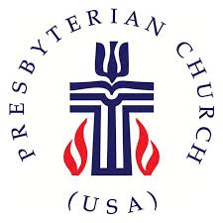

TUCKAHOE PRESBYTERIAN CHURCH
7000 Park Avenue, Richmond, VA 23226
804-282-2860; www.tuckahoepres.org

